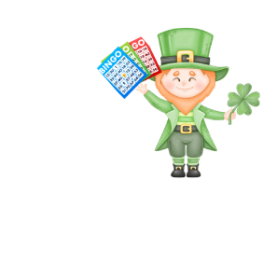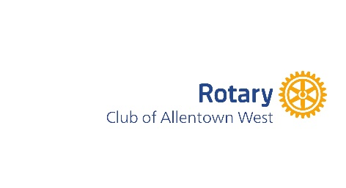
In-Kind Donation Letter

From: _____________________________ To: __________________________________
Sender’s Name Recipient’s Name

___________________________________ __________________________________

___________________________________ __________________________________
Sender’s address Recipient’s address

Dear ______________________________
Recipient’s name

I am a member of the Allentown West Club of Rotary International. Rotary’s vision is to see a world where people unite and take action to create lasting change – across the globe, in our communities and in ourselves.

We are planning a fundraising event to help Fight Lehigh Valley Hunger. We have a variety of projects to fight hunger for children and families in our local community. Please see our website (www.fightLVhunger.org) for examples.

Would you consider donating _______________?
Our March 17, 2024 fundraising event is a family-friendly event and is being held at the Macungie Memorial Hall from 2-5 PM, where we will be playing Irish Bingo. In addition to the fun generated during the games, we will be raffling one-of-a-kind gift baskets. For details about the event, please go to www.irishbingo.org or contact me at __________.

Please let me know if you can help us continue funding our humanitarian projects or if you would like more information about our organization.

Thank you,

Your name and contact information

